Navigation System Instructions

1. 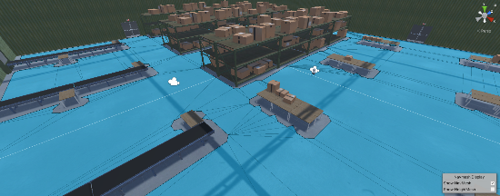Bake the navigation mesh, removing any artifacts.
2. Initialize 4 empty Game Objects named NavManager, Nodes, Edges, and Agents.
3. 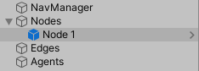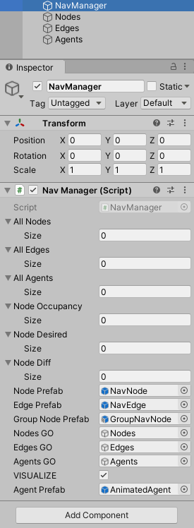Add the NavManager Script into the NavManager Game Object and drag the other three Game Objects into their respective slots as well as the Prefabs from “IVI/Prefabs”.
4. 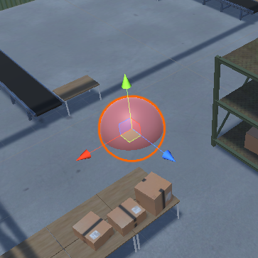Initialize a NavNode Prefab as a Game Object and place it as a child of the Nodes Game Object.
5. The NavNode is initialized with a script, which is used to construct the navigation graph.  
   The **Create Node** button initializes a new node that is connected to the current node through a NavEdge.  
   The **Create Group Node** does the same, but creates a node for grouping instead of navigation.  
   The **Create Connection** slot takes as input an existing NavNode and constructs a NavEdge between the current node and the added node.  
   The **Radius** determines how close an agent has to be to a node to be considered as occupying that node.  
   The **Spawn Count** controls the number of agents that spawn at the node at the start of the simulation. The agents are initialized from the 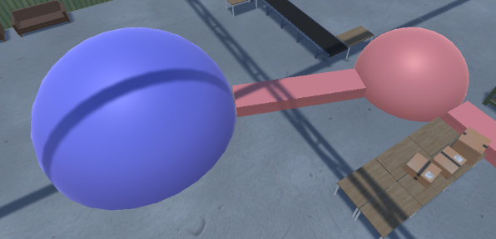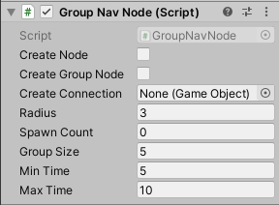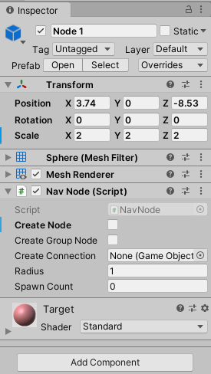**Agent Prefab** in the NavManager.
6. 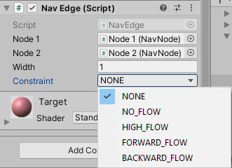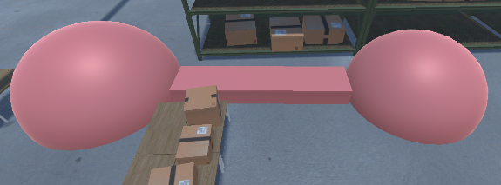After creating a NavEdge between two NavNodes, a constraint can be applied to force the flow of agents to be unconstrained, inhibited, excited, or unidirectional.
7. We recommend that the GroupNavNode is placed at the outskirts of the navigation graph, where it will not be utilized for navigation. This is because the number of agents that are permitted to use the node is constrained by the **Group Size**. Once an agent arrives at the node, it is registered with the node and its movement is halted for a random duration between the **Min Time** and **Max Time**. We recommend setting the spawn count to 0.
8. 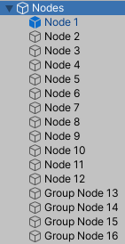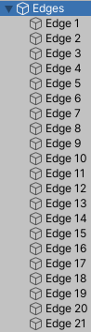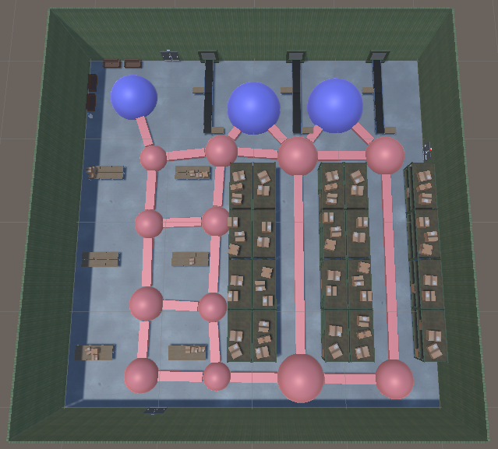After all nodes and edges have been created, the navigation graph and Game Object hierarchy should look like the below images.
9. During construction, deleting a NavNode will automatically delete its attached edges.